Isaac Asimov’s Treasury of Humor. Houghton Mifflin First Edition, First Print. 1971. Fine but clipped dust jacket. As new hardcover book with all 431 pages tight and clean, no marks at all. A Lifetime of favorite jokes, anecdotes, and limericks with copious notes on how to them and why. ISBN 0395126657

ID 0000100 Price $85

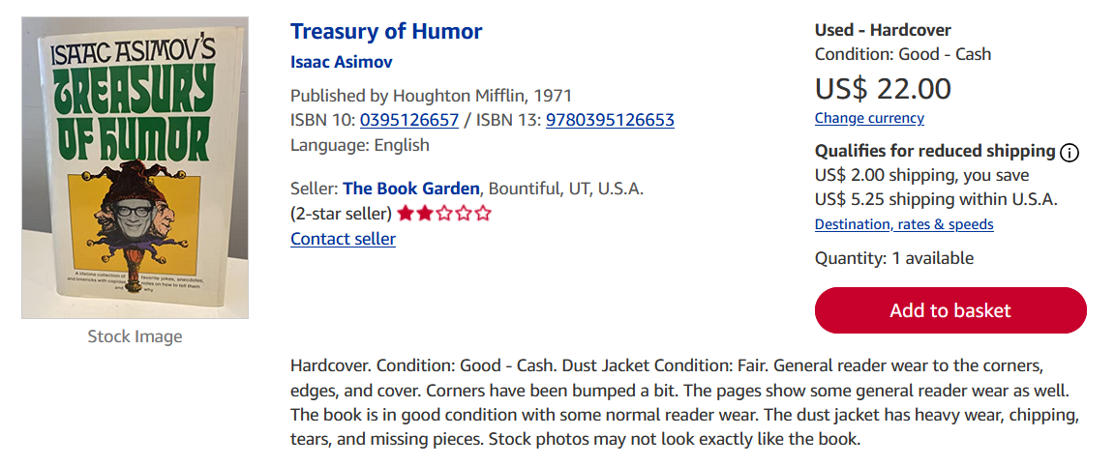
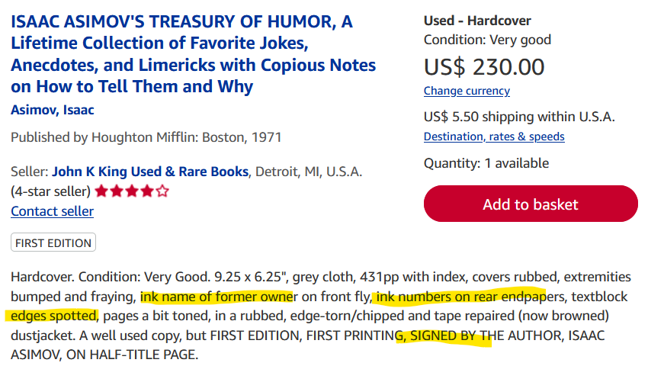
AbeBooks $9 to $230

